--------------------------------------------------------------------------------------------------------------------

Aditya Chikhalikar - B25CE1080
Ravin Godbole - B25CE1087
Sarthak Chawke - B25CE1079

----------------------------------------------------------------------------------------------------

EEL Report : Chess Openings Analysis Dashboard

- Aim

The aim of this experiment is to develop an interactive chess openings analysis dashboard using web technologies that can analyze and visualize chess data from a CSV file.The dashboard helps users understand opening popularity, performance, and trends through charts and filters.

- Research
Chess openings refer to the initial phase of a chess game, typically consisting of the first 10–15 moves. These moves are crucial as they establish control over the board, influence piece development, and determine the strategic direction of the game. Over centuries, openings have evolved from simple memorized sequences to deeply analyzed systems supported by databases and artificial intelligence.

Basic Concepts
- Openings are categorized using the ECO (Encyclopaedia of Chess Openings) codes
- Each opening has variations and families (e.g., Sicilian Defense, French Defense)
- Performance depends on:
  - Win %
  - Number of games played
  - Player rating

Objectives of the Study
- To understand different types of chess openings
- To analyze their performance using statistical data
- To study the evolution of opening theory
- To explore the role of modern tools in improving gameplay

History

1. Early Period
- Players relied on memorization and experience
- Limited availability of recorded games

2. Database Era
- Introduction of software like ChessBase
- Enabled storage and analysis of millions of games
- Facilitated statistical comparison of openings

3. Engine Era
- Engines such as Stockfish revolutionized chess analysis
- Provided highly accurate position evaluation
- Helped discover new strategies and improve existing ones

Principles of Openings
The main objectives of any chess opening include:
- Controlling the center (e4, d4, e5, d5)
- Rapid development of pieces
- Ensuring king safety (castling)
- Maintaining a strong pawn structure

ECO Classification System
The Encyclopaedia of Chess Openings (ECO) categorizes openings into codes ranging from A00 to E99.
- A00–A99: Flank Openings
- B00–B99: Semi-open Games (e.g., Sicilian Defense)
- C00–C99: Open Games (e.g., Ruy López, French Defense)
- D00–D99: Closed Games (e.g., Queen’s Gambit)
- E00–E99: Indian Defenses
This system standardizes classification and helps organize large datasets of chess games.

Major Chess Opening Families

1. Sicilian Defense
- Begins with: 1.e4 c5
- Nature: Aggressive and tactical
- Black aims for counterplay rather than symmetry
- One of the most popular openings at all levels

2. French Defense
- Begins with: 1.e4 e6
- Nature: Solid and defensive
- Strong pawn structure but limited bishop activity
- Leads to strategic, slower games

3. Ruy López (Spanish Opening)
- Begins with: 1.e4 e5 2.Nf3 Nc6 3.Bb5
- Nature: Positional and classical
- Focuses on long-term pressure and control
- Frequently played in professional tournaments

Performance Metrics in Opening Analysis

1. Win Percentage
- Measures the success rate of an opening
- Can vary depending on player strength and dataset size

2. Number of Games Played
- Indicates popularity and reliability
- Larger sample sizes provide more accurate insights

3. Player Rating (Elo)
- Openings perform differently at different skill levels
- Advanced openings are more effective for experienced players

Role of Online Platforms
Modern platforms like:
- Chess.com
- Lichess
provide:
- Access to large game databases
- Opening explorer tools
- Real-time analysis and feedback
These platforms have made advanced chess analysis accessible to players worldwide.

Modern Advancements in Data Analytics
Chess has become increasingly data-driven. Data analytics is used to:
- Identify popular and trending openings
- Compare performance across rating levels
- Prepare strategies against specific opponents
- Improve individual playing style

- Analysis
This project is important because:
- Helps players choose better openings based on data
- Makes large datasets easy to understand using graphs
- Useful for:
  - Beginners → learn popular openings
  - Intermediate players → improve win rate
  - Analysts → study trends
It converts raw CSV data into meaningful insights, which is a key concept in data science.

- Ideate
In this project, the idea is to build an interactive and modern dashboard that analyzes chess openings using data and presents it in a simple and visual format.

Project Theme
The theme of this project is a “Modern Data Analytics Dashboard”.
- Clean and minimal design
- Card-based layout for proper organization
- Soft gradient background with grid pattern
- Focus on:
  - Easy understanding
  - Smooth user interaction
  - Clear visualization
This theme ensures that large and complex data becomes easy to read and analyze.

Data Analysis in the Project
Data analysis is the process of collecting, processing, and extracting useful information from raw data.
In this project:
- Data is taken from a CSV file containing chess openings
- The dataset includes:
  - Opening name
  - Number of games
  - Player win percentage
  - Performance rating
  - Player statistics
The analysis process includes:
- Data Loading
  - CSV file is loaded and converted into usable format
- Data Cleaning
  - Handling missing values
  - Converting data into correct format
- Data Filtering
  - Users can filter data based on:
    - Opening name
    - ECO code
    - Number of games
    - Win percentage
- Data Visualization
  - Data is represented using charts and graphs
  - Helps in identifying patterns and trends easily

Importance of Data Analysis in Chess
Data analysis plays a very important role in modern chess.
- Helps players identify best openings based on win rate
- Shows which openings are most popular and effective
- Helps in understanding strengths and weaknesses
- Allows comparison between different strategies
- Improves decision-making using real data instead of guessing
By analyzing large numbers of games, players can:
- Choose better strategies
- Avoid weak openings
- Improve overall performance
This makes chess more data-driven and analytical rather than only based on intuition.

Core Functional Components
- Filters
  - Allow users to customize and explore data
- KPIs (Key Performance Indicators)
  - Show important values like total games and top opening
- Charts
  - Visual representation of trends and comparisons
- Table
  - Displays detailed filtered data

Working Principle
- CSV data is loaded into the system
- Data is processed and cleaned
- Filters are applied based on user input
- Charts and KPIs update automatically
- Final results are displayed in table and graphs

- Build

Main Logic Flow
- Load CSV file
- Convert data using Papa Parse
- Apply filters
- Update KPIs
- Render charts and table
Access to the files:
https://drive.google.com/drive/folders/1PoS7KjavLYoXGNAtYa_bLnsqtXQF8Xn6?usp=sharing

Testing (Output)

Dashboard successfully:
- Loads CSV data
- Displays charts
- Filters data in real-time

Output Features
- Interactive filters working
- Charts updating dynamically
- Table shows correct filtered results
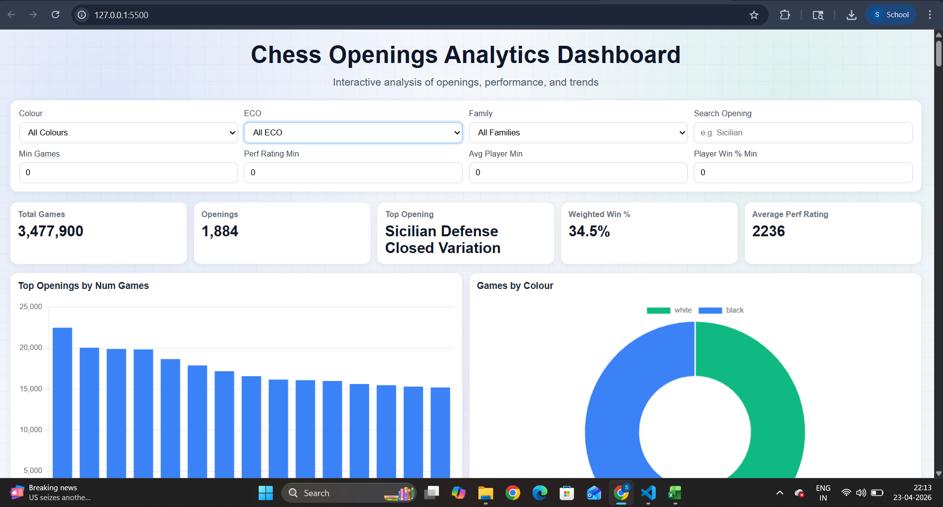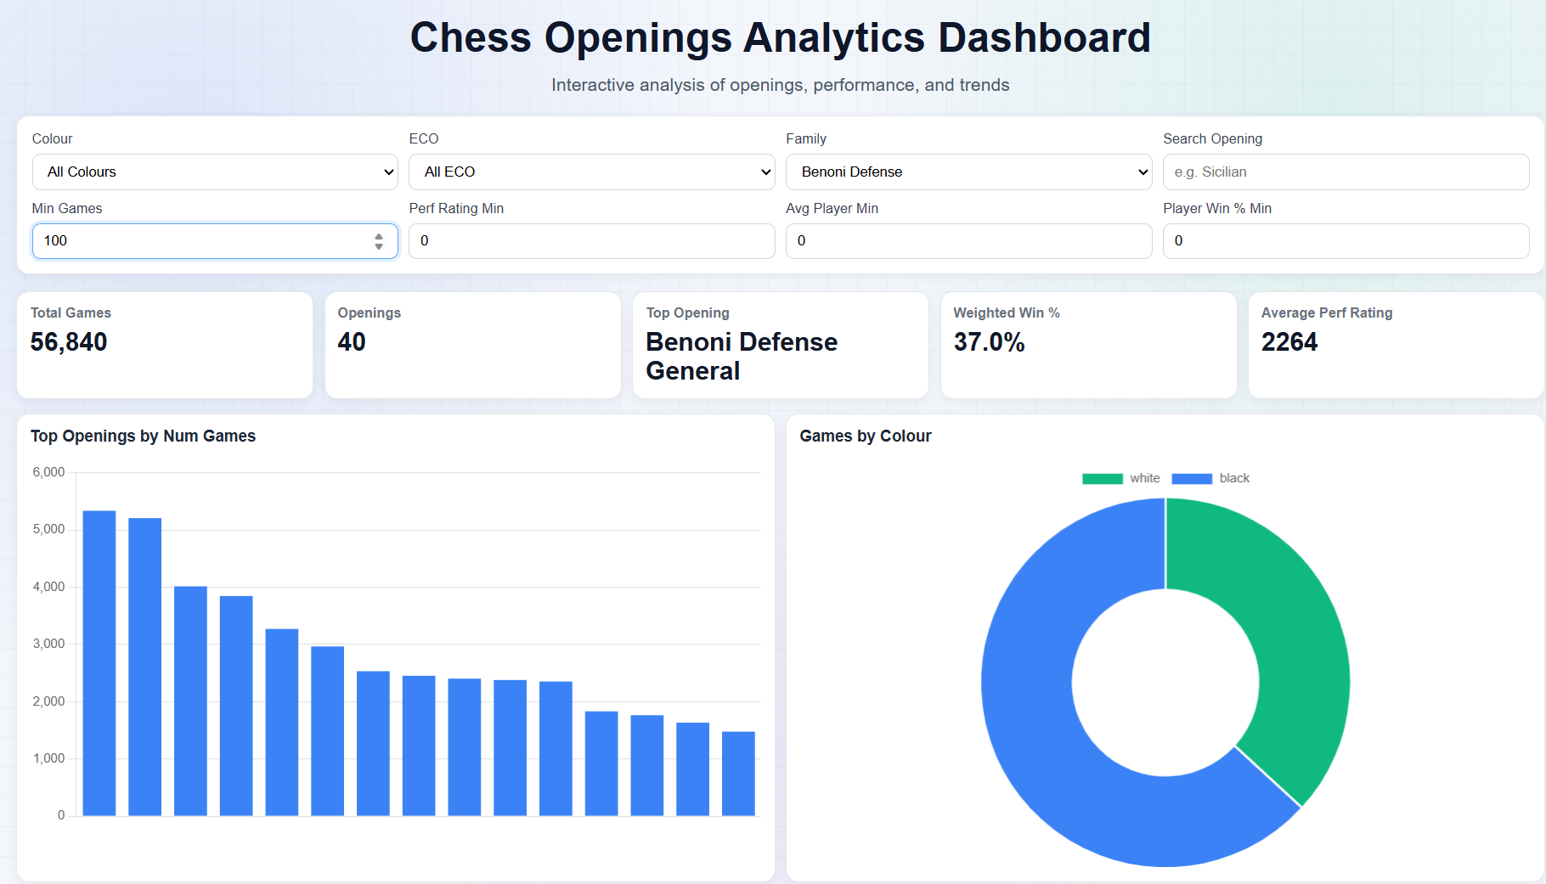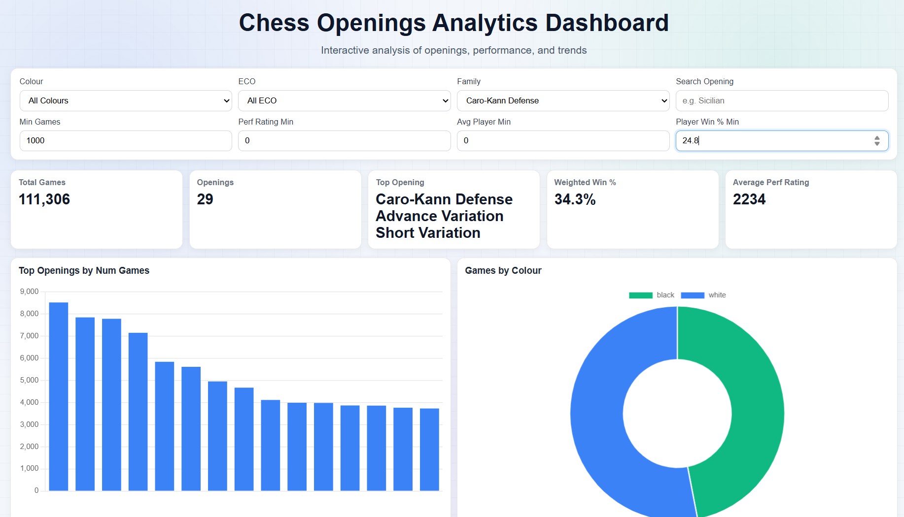

- Implementation
https://github.com/Ravin-Godbole-2025-comp/FY-Sem-2-Mini-Project-Chess-Analysis-Dashboard

- Conclusion
The project successfully demonstrates:
- Use of data visualization techniques
- Handling of real-world datasets
- Building a web-based interactive dashboard
- Integration of multiple technologies (HTML, CSS, JS)
It shows how data can be transformed into useful insights for better decision-making in chess.

